October 9, 2026
Claire and Mark Bennett
5874 Woodleigh Drive
Carmichael CA
95834
Dear Claire and Mark,
The following is a brief summary regarding Owen's orthodontic situation. You mentioned that Owen's mother had late eruption of her own teeth and required surgical help to bring in impacted teeth, which helps us understand why Owen's pattern of delayed eruption is something we are watching closely.
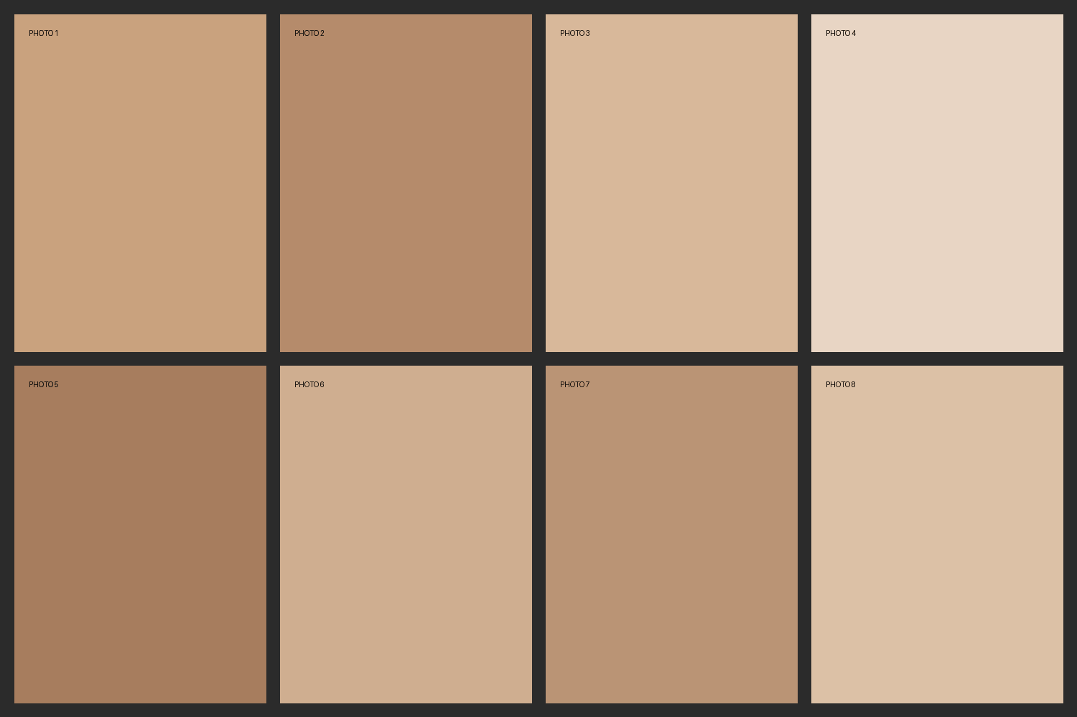
Dental Relationships
Owen's upper front teeth sit slightly ahead of his lower front teeth, and there is mild crowding in both arches.
Treatment Plan
• Palatal expander to create space
• Braces on the upper and lower teeth
Fees
The total fee is $6,860, with an initial payment of $860 and 24 monthly payments of $250.
Best,
Marc S. Lemchen, DMD

